**Homepage Testing Document**

**dns18cch**

# Instructions

You should document any testing of your webpage carried out here. You are not expected to write a whole essay on this: one or two pages at most should suffice (including screen shots). Ideally, you should check all HTML and CSS for correctness.

# Examples

**Example** tasks you might carry out (you are expected to give a bit more detail, and be specific about what you have done):

**Task 1. Cross-browser compatibility:**

All initial testing was done using Google Chrome. However, in IE 11 everything was displayed as expected except for images that were loaded from a local file. These images did not display, although images sourced from a URL displayed as normal.

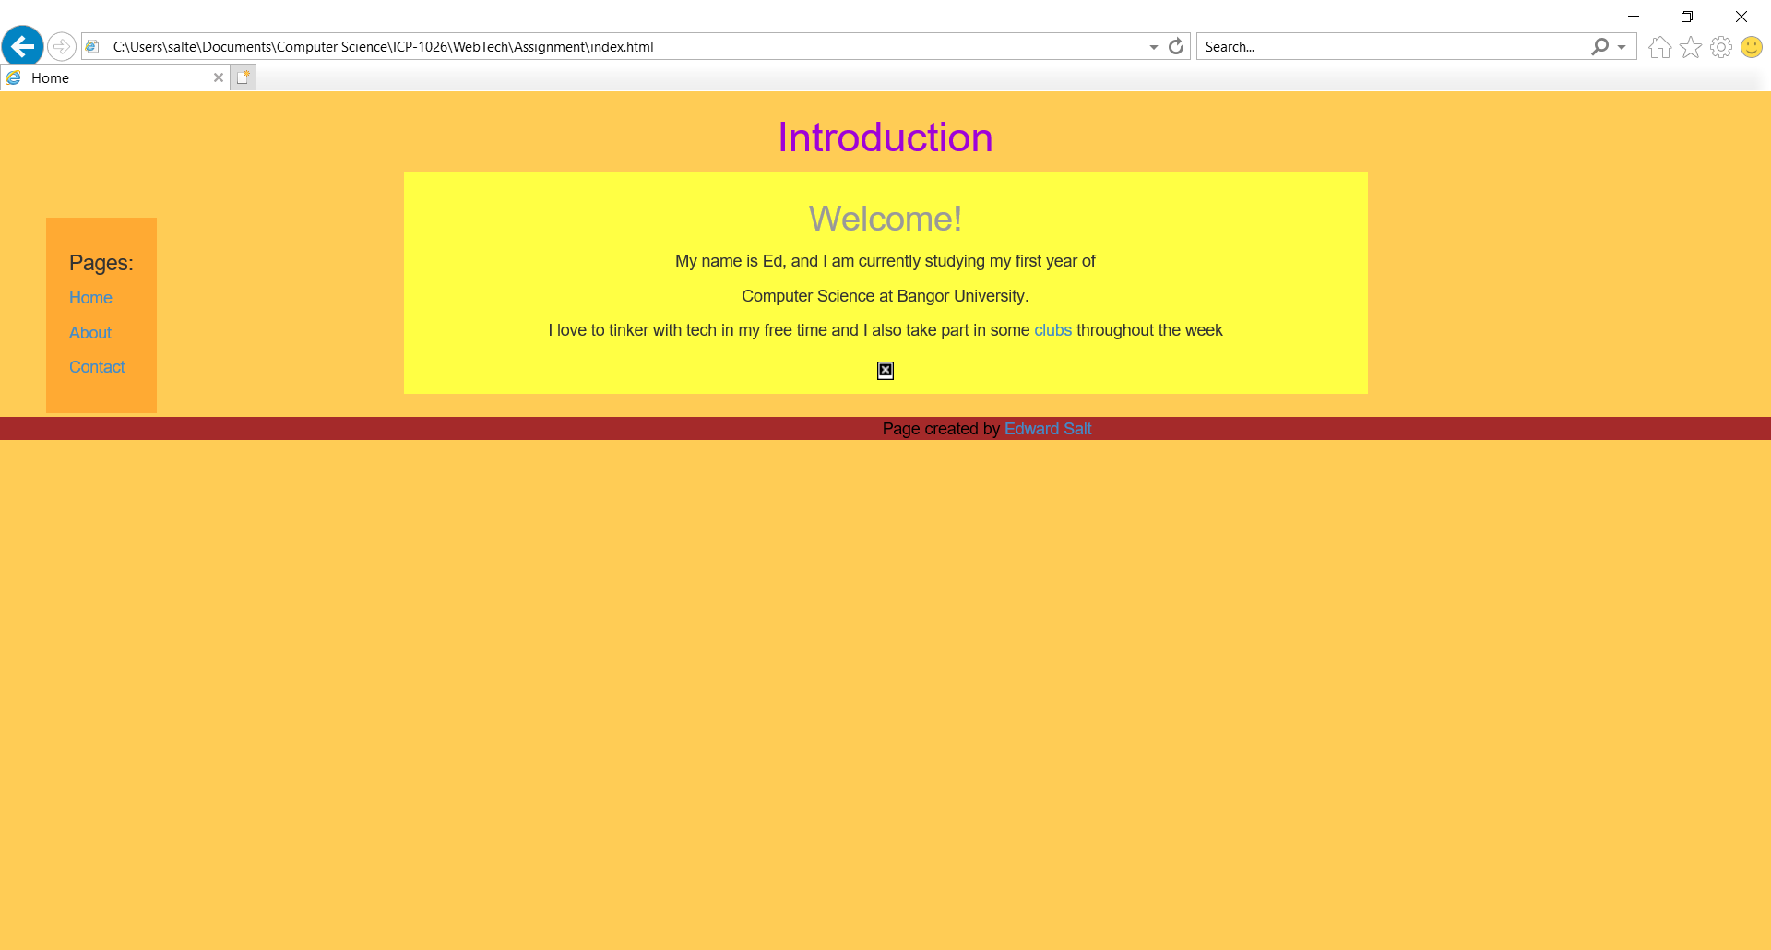

**Task 2. HTML/CSS Validation**

I used the W3C CSS validator to check my styling code. It detected only 1 error which was that I had unnecessarily included a ‘float: centre’ for the article styling. This line was removed and it found no more errors.

I then checked my HTML pages. The first, index, found 3 errors which were that the article lacked a heading; the footer was placed outside of the body tags; and the image element lacked an “alt attribute”. I fixed all errors except the last, as I was unsure what adding an alt attribute for an image meant.

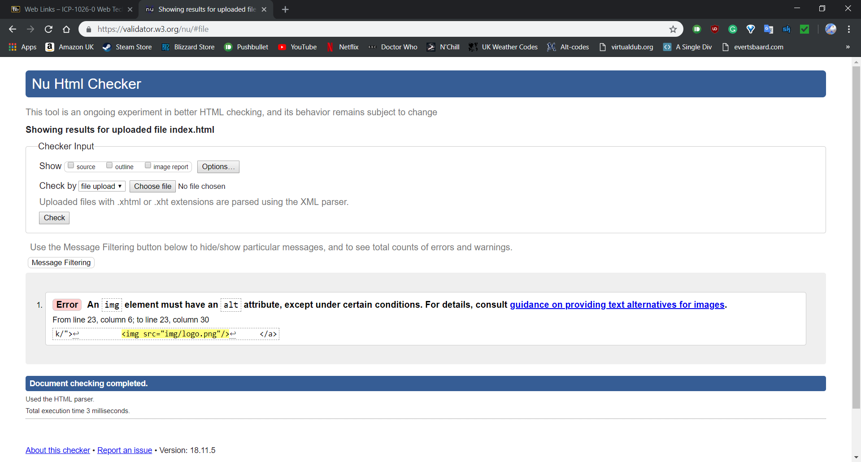

The about page was tested next. The only errors that were found were, again, for alt attributes for the two images on the page – which I couldn’t fix.

Finally the contact page was tested. There was another error for alt image attributes and another for the height value specified for the included image, as I had used a ‘/’ to close the img tag with no space after the height value. This was fixed.

**Task 3. Peer review**

I showed my pages to a friend, they found it easy to navigate between the pages and thought the content of each page was clearly laid out and easy to read. They didn’t realise that the image on the index page also had a link to the Bangor homepage, but all other links were visible.